Project Information Document (PID)

Appraisal Stage | Date Prepared/Updated: 21-Jan-2020 | Report No: PIDA26087

BASIC INFORMATION

OPS_TABLE_BASIC_DATA
A. Basic Project Data
Country | Project ID | Project Name | Parent Project ID (if any)
Indonesia | P165742 | ID: Strengthening of Social Forestry in Indonesia
Region | Estimated Appraisal Date | Estimated Board Date | Practice Area (Lead)
EAST ASIA AND PACIFIC | 20-Jan-2020 | 27-Feb-2020 | Environment, Natural Resources & the Blue Economy
Financing Instrument | Borrower(s) | Implementing Agency | GEF Focal Area
Investment Project Financing | Ministry of Finance (MOF) | Ministry of Environment and Forestry (MOEF) | Multi-focal area

Proposed Development Objective(s)
The Project Development Objective (PDO) is to improve access to forest land use rights and strengthen community management in selected priority areas allocated for social forestry

Components
Policy and institutional strengthening to support social forestry
Strengthening community management within social forestry
Project management and Monitoring and Evaluation

PROJECT FINANCING DATA (US$, Millions)

SUMMARY-NewFin1

Total Project Cost | 109.43
Total Financing | 109.43
of which IBRD/IDA | 0.00
Financing Gap | 0.00

DETAILS-NewFinEnh1
Non-World Bank Group Financing
Counterpart Funding | 95.11
Borrower/Recipient | 95.11
Trust Funds | 14.32
Global Environment Facility (GEF) | 14.32

Environmental and Social Risk Classification
Substantial

Decision
The review did authorize the team to appraise and negotiate

Other Decision (as needed)

B. Introduction and Context
Country Context

- The Indonesian economy has shown solid growth over the past decade, which has contributed to a significant reduction in national poverty. From 2001 to 2012, Indonesia’s gross domestic product (GDP) almost doubled and the country’s GDP per capita rose from US$2,737 to US$4,272 (in constant 2005 US dollars based on purchasing power parity) at an average annual growth rate of 4 percent. By 2015, Indonesia’s total GDP was US$1.3 trillion, positioning the country as the largest economy in Southeast Asia and the only Southeast Asian member of the G-20. The economic growth contributed to halving the national poverty rate from 24 percent in 1999 to 10.6 percent in 2017. Growth averaged 5 percent in 2016, but rose to 5.2 percent in third quarter of 2018, and is projected to remain steady at 5.2 percent in 2019. The country’s GDP per capita has steadily risen, from US$857 in 2000 to US$3,847 in 2017. The economy is based largely on the extraction of nonrenewable resources, which accounts for 16 percent of GDP and 40 percent of exports, respectively, and on renewable commodities, including timber and agricultural products.

- Indeed, agriculture and forestry contribute significantly to Indonesia’s economic growth; however, a large percentage of the population dependent on these sectors remains poorer than the national average. Agriculture and forestry together account for 34 percent of the country’s GDP. Thirty-three percent of the labor force depends predominantly or exclusively on agriculture, forestry, hunting, or fishing, and many others depend on related downstream activities. However, the people depending on forests and rural lands for agricultural livelihoods are disproportionally poorer than the national average and include many adat communities. According to 2014 government data, poverty in and around forest areas is estimated at 16.15 percent (or 5.6 million poor people out of a population of 34.8 million in and around forest areas), while poverty inside forest areas reaches 23.5 percent (or 0.3 million poor people out of a population of 1.2 million), which is more than double the national poverty rate. Within forest areas, poverty rates vary between areas with different forest classifications. Around 24.77 percent (or 0.2 million poor people out of a population of 0.8 million) of people living inside forest areas classified as protection forest are poor compared to 14.79 percent (or 2.1 million poor people out of 14.5 million people) in conservation forests.

- Commodity-driven land conversion has been associated with high environmental costs from deforestation, forest degradation, and greenhouse gas (GHG) emissions. While Indonesia has long been a major exporter and producer of timber products, in the last decade palm oil has become another major community export of the country. Agriculture, particularly oil palm, logging, and mineral extraction, together with rapid urbanization and housing development, have increased forest encroachment and conversion. Between 2010 and 2015, Indonesia had the second highest annual net loss of forest area in the world (after Brazil), equivalent to 684,000 hectares (ha) or 0.7 percent per year. According to government figures, there has been a slow improvement in the rate of forest loss over time, as shown in Figure 1. Despite the improvement, overall diminished forest cover, as well as rapid degradation of existing forests, led to reduced environmental services (such as biodiversity, carbon sequestration, and water provision) provided to the forest-dependent rural communities, further increasing the potential for poverty among these communities. Land-use change, particularly land conversion involving land and forest fires, is also responsible for two-thirds of Indonesia’s GHG emissions, the magnitude of which places the country among the top five GHG emitters globally.

Figure 1: Indonesia Deforestation Trends, 1999–2017 (millions of hectares)
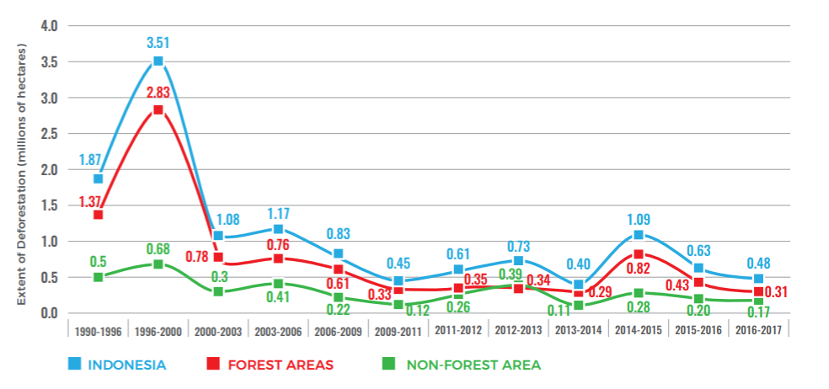
Source: MoEF 2018a, Figure 3.2.

- Indonesia is one of the world’s mega-biodiverse countries, with rich mammal, bird, and plant species, many of which are endemic but endangered, and threatened by habitat destruction and illegal harvesting or poaching. The country is home to iconic biodiversity such as Sumatran tiger, Sumatran and Javan rhinoceros, orangutan, Asian elephant, pangolin, anoa, babirusa, helmeted hornbill, yellow-crested cockatoo, and other parrot family species. Indonesia’s lowlands areas, which cover extensive low-lying forest landscapes on the islands of Sumatra, Kalimantan, and Papua, support significant peat and mangrove ecosystems harboring rich fauna and flora species of global, regional, and local significance from both biodiversity and climate change perspectives. Unsustainable management of forest landscapes and resources constitutes a key threat to conservation of Indonesia’s critical habitats important for globally significant biodiversity. Degradation and encroachment of these habitats, especially those under the conservation and protection forests, create risks to some of the iconic biodiversity species. For example, a study on Riau estimated that from the early 1980s to 2007, the population of Sumatran elephants in the province declined by 84 percent, and of Sumatran tigers by 70 percent, due largely to fragmentation of natural habitats. While there have been efforts to protect wildlife, more needs to be done to improve sustainable management of forest landscapes to reduce drivers of biodiversity loss from land conversion.

- President Joko Widodo’s Nawa Cita vision emphasizes the links between economic growth, poverty reduction, and sustainable natural resource management. Recognizing that reducing extreme poverty requires sustainable management of natural resources, including land and forests, and improving the rural economy broadly, the vision places agrarian reform as a foundation for national economic policy to reduce poverty and income gaps and create rural jobs. In the context of forest-dependant rural communities, improving clarity on forestland use and increasing community access rights are seen as key to improving the management and protection of forest resources while reducing poverty.

Sectoral and Institutional Context
- Indonesia’s land governance is characterized by a dualism in land administration practice. Under the Forestry Law of 41/1999, the state, through the Ministry of Environment and Forestry (MoEF), determined areas that are to be functionally maintained as permanent forests. These areas are known as the Forest Areas (Kawasan Hutan). The Forestry Law also recognizes two types of forest within the Forest Areas (Kawasan Hutan): (1) State Forest (Hutan Negara), or forest located on lands that have not been encumbered by any tenure right, and (2) Titled Forest (Hutan Hak), or forest located on lands that have been encumbered by a tenure right. The MoEF is responsible for managing the forest and administering the relationship between people and the forest in the forest areas (Kawasan Hutan), and management responsibility for all forest, including State Forest (Hutan Negara) and Titled Forest (Hutan Hak). This management responsibility forms the basis for the MoEF’s issuance of the various types of forestry licenses and permits in State Forest (Hutan Negara). Under the Basic Agrarian Law 5/1960, the administration of all lands regardless of their land cover (including forest cover) is the responsibility of the state through the Ministry of Agrarian and Spatial Planning/National Land Agency (ATR/BPN), which oversees the registration of all land and the issuance of various types of land tenure rights.

- The dualism in land administration practice leads to unclear legal recognitions of land rights and tenure arrangements in forest areas. In practice, this dualism has two important implications for the administration of forestland rights and tenure arrangements. First, partly because of the lack of sufficient data and maps, most of the Forest Areas (Kawasan Hutan) are in practice assumed to be State Forest (Hutan Negara); hence, the underlying lands are considered as state lands administered by the MoEF, and the forest Kawasan Hutan) boundaries are deemed to be state land boundaries , instead of functional boundaries (for example, boundaries required to maintain forest ecological functions). In the past, when a title of land belonging to a community located in Kawasan Hutan was to be issued, the MoEF would normally change the forest area designation for that land parcel into titled land, in effect taking such titled land out of the designated forest area (Kawasan Hutan) and reassigning it as Areas for Other Purposes (Areal Penggunaan Lain, or APL). This practice took place even though the Forestry Law does in fact recognize the existence of Titled Forest (Hutan Hak), which may include Private Forest and Adat Forest (Hutan Adat), within Kawasan Hutan. As a result of the practice of forest areas being treated as MoEF-administered state lands, the ATR/BPN has also largely restricted its role to issuing land titles in APL (that is, outside Kawasan Hutan). Second, while the Forestry Law is often interpreted to regard the relationship between people and forest as one of land tenure as opposed to only forest tenure, the Basic Agrarian Law adopts the principle of horizontal separation, where the ownership or tenure of the land may differ from that of assets on the land. These different principles adopted by the two laws contribute to lack of clarity and to uncertainties in administering land rights and tenure arrangements in forest areas. Annex 3 further elaborates on the land tenure system under Indonesian law and highlights the issues of dualism in land administration in Indonesia.

- The dualism in land administration practice impedes recognition of land rights for communities living in forest areas, limiting their access to resources and leading to land conflicts that simultaneously threaten the livelihoods of forest communities and contribute to forest loss and degradation. Given that all forest areas (Kawasan Hutan) have in practice been treated as state lands administered by the MoEF, community rights in these areas were in the past overruled by state control. This has led to long-term conflicts between communities (including adat groups) and the state. In many cases, asymmetric processes for recognition of forestland rights and use allocation have also led to conflicts between forest communities and private sector concessionaires that have been licensed to use forestland through forestry permits. A lack of effective conflict resolution systems results in persistent land conflicts, which make up about 60 percent of all legal cases in Indonesia. This unclear recognition of community forestland rights and the presence of land conflicts also impede the government’s ability to effectively prevent agricultural expansion onto forestlands. Indeed, forestland conversion for cultivation purposes is generally seen as a way to secure direct returns to the community and lead to permanent property and resource rights. Some landholders, enabled by unclear boundary demarcation, use fires to clear land and burn beyond their concession boundaries as part of a land acquisition effort.

Baseline:

- Improving forest community livelihoods through tenure management has become a government priority. In 2018, the Government of Indonesia (GOI) enacted Presidential Regulation 86/2018 on Agrarian Reform. The regulation is the follow-up to People’s Consultative Assembly Decision Number IX/MPR/2001 prescribing the principles of a policy to maximize the benefits of natural resources for the welfare of the people and to rectify the disparity in land control. The policy includes redistribution of state lands, including those (4.1 million ha) deriving from Kawasan Hutan to the landless population with the goal of resolving conflicts and providing access to capital resources for earning a livelihood. The lands that become the object for redistribution and legalization are formally referred to as Tanah Obyek Reforma Agraria (TORA). TORA is defined as lands under state control for redistribution or community lands that need to be legalized. Article 7(1) (d) of the Presidential Regulation stipulates that when the TORA come from the State Forest (Hutan Negara), which is part of Kawasan Hutan, the land tenure can be transformed from state land to titled land without necessarily changing the functional status of the land, hence becoming Titled Forest (Hutan Hak). In practice, this could mean that the control of forest areas (Kawasan Hutan) could be transferred from the state to the community through community tenure, while such land remains designated as Kawasan Hutan, hence the need for community involvement in forest management. Within such a context, a forest management scheme that supports the communities in managing and using forests (that is, the Social Forestry Program) under different tenure types would be critical both to both resolving the problems around overlapping tenure claims and at the same time maintaining forest cover.

- Improving community access to forestland use rights could contribute significantly to reducing land conflicts, optimizing land using planning, and protecting forest resources. The clarification of boundary and land titles, which define use rights given to the underlying land, for communities in forest areas will provide more certainty in land governance, which is needed to enforce laws and regulations designed to manage land use. If implemented, the features of the Forestry Law that recognize the existence of Titled Forest within forest areas (Kawasan Hutan) could potentially provide a solution to tenure conflicts on lands located in such areas.

- The Social Forestry Program (SFP) is considered a strategic approach to addressing the drivers of forest degradation, deforestation, and poverty, and contributes to the GOI’s national poverty alleviation program. The SFP, along with the overall agrarian reform (TORA), are integral components of the GOI’s equitable economic policy. Launched in 2015, the policy aimed to reduce inequality by ensuring the availability of land for members of local communities, including adat communities, and the achievement of social justice in the use of forest resources by these communities throughout Indonesia. Social forestry is an approach to forest management and protection that prioritizes social and environmental development through the restoration of degraded forestlands. The GOI aims to use the SFP to address the systemic poverty by selecting, demarcating, and registering lands in forest areas as community-managed, while simultaneously enhancing forest management and restoration in the buffer zones of critical protected areas. The latter is expected to help reduce the pressure to convert old-growth forest for agriculture and generate global environmental benefits (for example, conservation of the biodiversity of global significance and mitigating GHG emissions).

- Achieving the social forestry objectives and targets could play a key role in sustainable management of Indonesia’ forests from the perspectives of land and forest fire prevention, climate change mitigation, and livelihood development. In recent decades, Indonesia’s forestlands have been significantly converted for the expansion of timber and agriculture, particularly food crops, and more recently oil palm plantations. Drainage-based agriculture, particularly on peatlands, has resulted in increasingly fire-prone landscapes, with significant costs to the Indonesian economy and the poor. Almost 80 percent the extensive 2015–16 fires occurred within eight fire-prone lowland provinces. Fires like that are also the major source of Indonesia’s globally significant GHG emissions. As discussed in paragraphs 7 and 8, weak land administration and insecure tenures are a key driver of recurrent man-made land and forest fires. By creating more certainty for community land use rights and land tenures in forest areas, social forestry can contribute significantly to addressing a key driver of man-made fires and improving the enabling conditions for sustainable forest management.

- The SFP also provides an opportunity for the GOI to engage communities and smallholder farmers in its biodiversity conservation effort. By providing use rights to severely degraded forestland to communities, the SFP helps reduce the drivers of biodiversity loss by (i) supporting sustainable community-based forest management to increase forest cover, which in turn provides biodiversity dispersal or corridor benefits; and (ii) promoting forest-based micro- and small enterprise development to improve the livelihoods of forest-dependent communities, thereby reducing conversion pressure on intact forest habitats.

- The current implementation of the SFP limits its scope to only the four types of schemes that facilitate community use of State Forest and excludes one scheme that supports communities in managing forests in adat and titled lands. The four schemes that apply to State Forest, regulated under an MoEF decree, include Community Forestry (Hutan Kemasyarakatan, HKm), Village Forestry (Hutan Desa, HD), Community Plantation Forest (Hutan Tanaman Rakyat, HTR), and Forestry Partnership (Kemitraan Kehutanan, Kemitraan) (Box 1). Customary Forest (Hutan Adat, HA), which applies to adat forests, and Community Forestry on Titled Land (Hutan Rakyat, HR), which applies to titled forests (forest on private lands), are not included (Box 1). If adat and community forests were included, the SFP could contribute more to social inclusion in the broader national context, and it could strengthen the position of the Social Forestry initiative in supporting the minimization of land tenure conflicts in the forest areas, and to aligning with global good practices with regard to community participation in sustainable forest management. This inclusion will require the SFP to be open to land tenure assessment in the forest areas (which can be supported by the World Bank’s Program to Accelerate Agrarian Reform), resulting in (i) titled forests for those lands whose tenure claims are proven to be legitimate, and (ii) Social Forestry Permits for those whose tenure claims do not meet the requirements for tenure rights. A further description on the need for collaboration between the SSF project and the World Bank’s Program to Accelerate Agrarian Reform is presented in the Project Appraisal Document Annex 4.

Box 1: Social Forestry Schemes in Indonesia
- Community Forestry (Hutan Kemasyarakatan, HKm) is a scheme to give forest access and capacity building tools to community groups so they can manage forests in a sustainable way. Areas targeted include production and protection forests that are not under license and have potential uses (for example, timber and non-timber forest products [NTFPs], environmental services [ecotourism, hydrology, carbon storage, and sequestration], medicinal plants, agrofishery, and agrosilvopastoral practices).

- Village Forestry (Hutan Desa, HD) provides forest access to villages for sustainable management. Target locations for the HD scheme are production and protection forests that are not under license. Potential uses of the HD scheme are similar to those of HKm.

- Community Plantation Forests (Hutan Tanaman Rakyat, HTR) are state forests that are managed by individuals or cooperatives to increase quality and potency of forest products (timber and NTFPs). HTRs have a maximum area of about 15 ha for each license holder or 700 ha for cooperatives. Individual license holders can form community groups to request a single license. The target location for HTRs is in production forests.

- Customary Forests (Hutan Adat, HA) are located in adat community areas and managed by the communities’ customary law (masyarakat hukum adat). Customary forests can be located in production or protection forests, on private land (outside forest estates), or in state forests. Potential uses under this scheme include timber and NTFPs (using local customary practices) or designating land for protection purposes. Customary law communities are legally recognized through regional regulations (Peraturan Daerah, PERDA).

- Forestry Partnerships (Kemitraan Kehutanan, Kemitraan) are state forestlands managed by community groups or cooperatives to give access and direct benefit to local communities through capacity strengthening in cooperation with concession holders and forest management units (FMUs). Target locations for Kemitraan are areas under concession in production forest and in specific areas (wilayah tertentu) based on FMU management planning. Kemitraan can include uses of timber and NTFPs, environmental services, medicinal plants, silvofishery and agrosilvopasture.

- Community Forestry on Titled Land (Hutan Rakyat, HR) is managed by community groups and cooperatives located on private lands. HR-designated areas can be used for timber, NTFPs, and environmental services.

- SFP activities have so far been principally financed through the MoEF’s budget. The 2015 to 2019 Social Forestry target to award social forestry permits covering 12.7 million ha was set by the National Medium-Term Development Plan (RPJMN). To achieve this target, the GOI has allocated central government budget funds to the Directorate General of Social Forestry under the MoEF for disbursement to communities through MoEF provincial offices, resulting in the expensed budgets of US$5.5 million in 2016 and US$3.5 million in 2017. These expensed budget amounts were close to the allocated budget amounts for both years. In 2018, the allocated MoEF budget for social forestry jumped to around US$20 million. While the data on how much of this 2018 budget was actually used have not yet been released, the increased allocation indicates the GOI’s intention to expedite implementation of the SFP.

- Other budget and non-budget resources could be further leveraged to finance activities that lead to social forestry outcomes. Apart from this GOI’s budget allocation to the MoEF, there are two other budget-based instruments that could in principle be used for social forestry. First, communities can access revolving funds under the Public Development Center for Forest Development Financing (P2H Center BLU) scheme, which is managed by the MoEF for activities related to timber and non-timber forest products and enterprises. For example, in the Blora District of the Central Java Province, the P2H Center BLU signed a loan agreement with members of three Community Forest Farmer Groups, comprising 35 farmers, to postpone the cutting of community forests, with a total loan commitment value of IDR 1,136,380,000. In addition, an upcoming BLU on Climate Change and Reducing Emissions from Deforestation and Forest Degradation (REDD+), which is designed to accept results-based payments and will be operationalized in June, could also provide additional funding in the future. Second, fiscal transfers from the central government’s budget to local governments through various funds could finance activities that contribute to social forestry objectives. For example, provinces and districts can access funding from the Revenue Sharing Fund for Reforestation (Dana Bagi Hasil Sumber Daya Alam Dana Reboisasi, DBH DR) for reforestation and related facilitation activities, while local communities in villages can access the Village Funds for social forestry activities, such as enterprise development, if they consider them a priority. In addition to the budget-based financing instruments, Indonesia could also consider leveraging international climate finance, such as the Green Climate Fund, REDD+ financing, and bilateral aid; payment for ecosystem service schemes; and the issuance of green bonds as potential sources of financing for activities that could contribute to social forestry objectives.

- Despite strong political support, implementation of the SFP has been slower than expected. To date, the SFP has issued permits covering about 1.72 million ha (4,581 licenses, covering +/- 384,816 households). The original target of 12.7 million ha, which was expected to be achieved by 2019, has been reduced to 4.38 million ha to reflect what might realistically be achieved within that time frame. A new target delivery date of 2024 has been set for accomplishing the 12.7 million ha target. This adjustment has been made due to various challenges the program has faced including the difficulties in identifying and transferring appropriate degraded forestlands; weak capacity at the community level to access information, markets, and technical assistance; and limited institutional capacity and incentives at the national and local government level in implementing the social forestry schemes.

- To facilitate and expedite social forestry rollout, a number of regulations and tools have been established since 2015. These include simplification of regulations and procedures on social forestry with technical implementation guidelines, and issuance of supporting ministerial regulations, including on social forestry (P83/2016), private forests (P32/2015), forestland tenure conflict management (P84/2015) and social forestry in Perhutani (state-owned company) areas (P39/2017) in Java. The MoEF also introduced corrective actions to help accelerate implementation of the SFP, providing supporting regulations and systems that include a web-based licensing system, Working Groups for the Acceleration of Social Forestry (POKJA PPS) at the provincial level, the social forestry site blueprint, and the Indicative Map of Social Forestry Area (Peta Indicative Area Perhutanan Sosial, PIAPS). The PIAPS is an online map that describes areas within state forest allocated for social forestry. The map is developed based on harmonization of existing maps of the MoEF with maps provided by nongovernmental organizations and civil society, including results of consultations with local government and other stakeholders. PIAPS covers 13.9 million ha (of which the largest area is in Papua with 2.4 million ha, followed by Central Kalimantan with 1.8 million ha, Riau with 1.4 million ha, and West Kalimantan with 1.3 million ha). The map will be revised every six months to adjust to expired or new community-based forest management permits.

- The GOI has requested all its development partners to support its effort in achieving the ambitious target of 12.7 million ha for the SFP. Several development partners have joined hands with the GOI in this program including Forest Investment Program (FIP) supported by ADB and the World Bank, FAO, GEF/UNDP and the Government of Germany. The Government of Germany’s support through the KfW is focused on East Java, West Nusa Tenggara, and East Nusa Tenggara. The €11.5 million project, which is expected to begin implementation in late 2019, will support implementation of social forestry schemes to ensure sustainability to draw lessons for replication. The focus will be on supporting the implementation of activities post-permit issuance. It will help communities in developing enterprises for improving livelihood and ensuring sustainability. While the SSF project is also supporting activities in these provinces, there is no site-level overlap between the SSF project and the KfW-financed project. The World Bank and KfW are coordinating closely on these complementary programs. FAO supported project is under discussion/identification with the DG of Social Forestry. GEF/UNDP supported project provide complementarity in which SSF would contributes to better management of critical habitat which directly would contributes to the GEF/UNDP support project objectives. All these projects are overseen by the Director General (DG) of Social Forestry. The DG has ensured that there is no overlap/duplication of the effort and hence, the geographic focus of these projects are different. Program Coordination Unit (PCU) would be established that would coordinate and oversee ongoing (and planned) donor supported initiatives to ensure synergy and avoid duplications. The PCU would be financed by the donor supported projects, under the direction of the Director General of Social Forestry.

GEF Alternative:

- Despite the existing tools and regulations to support social forestry, there are significant policy and regulatory gaps to be addressed to expedite and facilitate implementation of the SFP. Despite being a national priority, the program still needs to be further internalized within the MoEF, and mainstreamed with other government agencies, as it is still largely perceived by many national-level government agencies as a sectoral program of the MoEF. Currently, a new national regulation in the form of Presidential Decree pertaining social forestry is being discussed. The new regulation is expected to strengthen coordination between the MoEF and multisectoral government agencies and mainstream the SFP into their programs. At the subnational level, the main challenges for social forestry implementation stem from the lack of direct authority and clear responsibility of districts in dealing with forestry issues due to the enactment of Law 23/2014 on local government, and from limited integration of community development objectives into forest mapping and spatial planning at the provincial and district level. However, there are existing district-level programs on poverty reduction, community empowerment, disaster management, and ecosystem restoration, which provide alternative implementation entry points to integrate the social forestry objectives.

- While accelerating the issuance of social forestry licenses and strengthening the supportive policy and regulatory frameworks remain important, supporting the communities to sustainably use and manage the forest resources after receiving the permits is key to the success of the SFP. The current implementation of the SFP provides limited support to strengthen the community’s capacity to prepare social forestry license applications or for the required management plans. A critical “half” of the SFP that has been neglected is the support to enable diverse communities to sustainably manage forests after they have received the permits. The proposed project contributes to the SFP through strengthening policy, institutions, and community capacity; piloting specific schemes; and developing tools that could be readily scaled up to meet the GOI’s ambitious target under the SFP. In addition, the current Social Forestry policy and program need significant strengthening beyond focusing on activities within the boundary of State Forest to include activities that also support social forestry activities on private lands, such as technical assistance for harvesting and managing private and community-owned forests. This expansion will allow social forestry to be fully implemented as an approach to forest management and protection that prioritizes socioeconomic development and environmental management through the restoration of degraded forestlands, including for global benefit.

- The proposed GEF supported project (hereafter referred as “Strengthening of Social Forestry in Indonesia” (SSF) contributes to the SFP through strengthening policy and institutions, community capacity, piloting specific schemes and developing tools which could be readily scaled up to meet the GOI’s ambitious target under the SFP. In addition, the current Social Forestry policy and program need significant strengthening beyond focusing on activities within the boundary of State Forest to include activities that also support social forestry activities in private lands, for example, technical assistance for harvesting and managing private and community-owned forests. This expansion will allow social forestry to be fully implemented as an approach to forest management and protection that prioritizes socio-economic development and environmental management through the restoration of degraded forest lands to generate global environment benefit besides local and regional benefits (see below Theory of Change).

Figure: Theory of Change

Activities | Outputs | PDO outcomes | Impact
1. Policy and Institutional Strengthening to support Social Forestry | - Harmonized relevant policies, regulations and procedures to expedite and facilitate the implementation of the GOI’s Social Forestry Program (SFP).  - Strengthened Institutional capacity of GOI to promote the SFP.  - Increased knowledge generation, system enhancement and management at district, | 1. An enabling environment is created for the successful development and strengthening of Social Forestry in Indonesia. | 1.Improved sustainable management and protection of forest resources.  2.Increased area of production landscapes that integrate conservation and sustainable use of biodiversity into management
2. Strengthening Community Management within Social Forestry | - Improved capacity of communities in formulating sustainable forest management plans.  - Strengthened community enterprises to implement sustainable livelihood models.  - Improved capacity of communities/farmers groups to develop and implement community livelihood investment | 2. Effective and efficient implementation of the SFP for enhancement of the sustainable management of the forest areas and socio-economic well-being of the villagers.
3. Effective and Efficient Project Implementation of the project activities (Project management | Strengthened capacity for project implementation and monitoring of the selected social forestry groups, social forestry facilitators and government agencies to expedite the implementation of the GOI’s SFP. | 3. Improved project management capacity to implement the SFP

- With incremental GEF resources, the SSF project would target the transfer and improved management of at least 300,000 ha of degraded lands and improve the protocols and information base for scaling up to the overall Social Forestry Program. By targeting degraded lands that are located in or near globally significant biodiversity areas, the SSF project also contributes to the conservation of biodiversity especially through the protection of corridors and improved management of buffer zones to important habitats. In order to ensure that GEF-supported activities further biodiversity conservation objectives, the MoEF used a set of site selection criteria to select the project intervention areas (see annex 1). Furthermore, the project provides technical and financial assistance to communities with the Social Forestry permits to adopt sustainable livelihood models to improve their wellbeing, and thus, mitigating the conversion pressure on critical habitats by the communities who otherwise would likely encroach these areas for short term economic gain.

Relevance to Higher Level Objectives

- The overall design of the Strengthening of Social Forestry in Indonesia (SSF) project is fully consistent with the objectives of the SFP, which is implemented by the GOI under the Agrarian Reform agenda. As one of President Jokowi’s policy priorities, the GOI’s SFP has three main objectives: 1) to provide access to forest land use rights to communities covering 12.7 m. ha; 2) to increase forest cover in the degraded forest land allocated to social forestry; and 3) to improve community livelihoods, including by supporting development of community small and medium enterprises (SMEs). This GEF-financed SSF project is designed to support these GOI’s SFP objectives and bringing value-added by: 1) harmonizing sub-national and national policy and regulatory frameworks and strengthening coordination and capacity of government institutions to expedite the implementation of the GOI’s SFP; 2) putting in place a mechanism for enhancing the transparency of information on social forestry boundaries by strengthening the PIAPS, and on other boundaries by linking to the World Bank’s Program to Accelerate Agrarian Reform (in selected sites); 3) developing or strengthening a land information and inventory system that provides consistent and comprehensive information on land claims including adat claims inside forest areas, particularly in the SSF project sites, and use the information to resolve land conflicts; 4) providing technical assistance to communities to acquire the forest land use permits or to manage titled forests under the GOI’s SFP and, after acquiring these use or land tenure rights, to formulate and implement sustainable forest management plans and enterprise/business development plans; and 5) providing technical assistance to key facilitators of the GOI’s SFP, including community-based organizations (CBOs) and non-governmental organizations (NGOs), so that they can effectively support communities with social forestry schemes. As such, this proposed SSF project is an integral part of the overall GOI’s SFP, and will help address the critical challenges currently facing social forestry in Indonesia, including delays in issuing social forestry permits as well as capacity constraints of communities, government institutions and non-government facilitators in both pre-and post-permit stages. The lessons learned along with enhanced capacity of the GOI’s SFP through this SSF project will enable the DG Social Forestry to scale up its activities beyond the current target under the project, eventually improving outcomes toward the 12.7m ha target of the overall SFP. To support this SSF project, the MoEF has allocated additional resources including a commitment of all Director Generals (DGs) under the Minister’s leadership within the MoEF to support project implementation. Considering that the proposed project would likely start its effective implementation in late 2019, it could also contribute to the mainstreaming of social forestry in the next Medium-term National Development Plan (RPJMN) for 2020-2025.

- This proposed SSF project is fully aligned with the Indonesia-World Bank Group (WBG) Country Partnership Framework (CPF) 2016-19. Calling for forward-looking management of Indonesia’s natural resources, the CPF supports sustainable landscape management and a policy reform agenda including improved land and forest governance and administration. Specifically, the proposed project would be part of the WBG Sustainable Landscapes Management (SLM) program in Indonesia. The SLM program supports the GOI to: a) sustainably manage high-value landscapes, including forests and peatlands, through conservation, restoration and sustainable development; b) improve land information systems by contributing to Agrarian Reforms; and c) improve forest management, including through strengthening the National Fire Management System by introducing risk based and prevention-focused approaches, and supporting implementation of the Reducing Emissions from Deforestation and Forest Degradation Program (REDD+).

- The proposed project would contribute to the objectives and strategies of GEF-6 on forest and biodiversity conservation. The project would contribute to enhancing forest cover by rehabilitating degraded forest land in selected project areas into well managed forest. The proposed project sites would generate environmental benefits including strengthening biodiversity conservation such as for critically endangered species (e.g., orangutans and Sumatran tigers), reversing land degradation and sustainable forest management. Therefore, it would contribute to the GEF-6 Biodiversity Focal Area Objective 4 (Mainstreaming Biodiversity Conservation and Sustainable Use into Production Landscapes), especially Program 9 (Managing Human-Biodiversity Interface). The project would also contribute to the objectives of GEF-6 Land Degradation focal area and Sustainable Forest Management (SFM) objectives through increased forest area coverage and improving management/restoration of forest lands. It would also contribute to the SFM objectives especially SFM-1 (Maintained Forest Resources: Reduce the pressures on high conservation value forests by addressing the drivers of deforestation); and SFM-2 (Enhanced Forest Management: Maintain flows for forest ecosystem services and improve resilience to climate change though SFM). Specifically, the project will address the following GEF-focal area specific indicators: (i) intact vegetative cover and degree of fragmentation in production landscapes measured in hectares; (ii) improved livelihood in rural areas; and (iii) enhanced sustainable livelihoods for local communities and forest-dependent people.

- The project is consistent with the Indonesia’s Biodiversity Strategy and Action Plan of 2015-2020, the Aichi Biodiversity Targets and Sustainable Development Goals (SDGs). The project contributes to the objectives of Indonesia’s Biodiversity Action Plan especially through the restoration of degraded forest land and conservation of important forest areas critical for biodiversity such as habitats for iconic Indonesian wildlife. Furthermore, the project will contribute to Aichi Biodiversity Targets 1, 7, 15 and 18.

- The SSF project’s innovation is inherent in its the integration with the Bank's overall engagement in the Sustainable Landscape Program especially with the World Bank’s Program to Accelerate Agrarian Reform, the World Bank-Financed Forest Investment Program (FIP), the Dedicated Grant Mechanism (DGM) and REDD+. The SSF project has a strong synergy with the national base-mapping exercise and forest boundary definition under with the World Bank’s Program to Accelerate Agrarian Reform – which collects information on the location and boundary of forests in priority biodiversity-rich and fire-prone areas. Given that effective implementation of the GoI's SSP requires accurate and agreed information on the boundaries and locations of degraded forests, as well as improved procedures to expedite transfer of use rights of lands to communities, strong linkages between the SSF project and the World Bank’s Program to Accelerate Agrarian Reform will enable the GoI to significantly advance their social forestry objectives. For example, the SSF project would go beyond mapping to provision of use rights, tools and resources for communities to develop and implement management plans to sustainably mange the land to increase forest cover and generate environmental services including biodiversity, climate mitigation and land degradation.

- In addition, the project contributes directly to Indonesia’s national climate policy objectives. For climate change mitigation, social forestry will contribute to reducing GHG emissions in the land use sector by reducing deforestation and forest degradation, restoring ecosystem functions, and promoting sustainable forest management. Certainty in spatial planning and land use, as well as land tenure security, are also considered enabling conditions for strengthening climate resilience in Indonesia. Increased tenure security and land use clarity through social forestry activities would provide incentives for households and communities to adopt climate-resilient agricultural practices through long-term investments, thus contributing to strengthening capacity of these communities to adapt to climate change.

C. Proposed Development Objective(s)

Development Objective(s) (From PAD)
- The Project Development Objective (PDO) is to improve access to forest land use rights and strengthen community management in selected priority areas allocated for social forestry.

Key Results

- PDO Level Indicator 1: Area under social forestry schemes with SF permit accorded to communities (Ha)
- PDO Level Indicator 2: Land area under sustainable landscape management practices (Ha)
- PDO Level Indicator 3: GHG Emissions mitigated (MtCO2e)
- PDO Level Indicator 4: People in targeted forest and adjacent communities with increased monetary or non-monetary benefits from forests (% of which are women)

B. Project Components

Component 1 - Policy and institutional strengthening to support social forestry (Total: $19.235M of which GEF financing: $2.536M):

- The objective of this component is to create an enabling environment for the successful development and strengthening of social forestry in Indonesia, and to allow for future sustainable scale-up of activities. There are three subcomponents.

- Subcomponent 1.1: Policy and regulations. The objective of this subcomponent is to support the MoEF in developing and harmonizing the relevant policies, regulations, and procedures to expedite implementation of the GOI’s Social Forestry Program (SFP). This subcomponent would also support mainstreaming social forestry objectives in other relevant sectoral policies and programs. Key activities include:

- Support the development of subnational level policies and regulations consistent with Social Forestry Program objectives. The project would support the drafting and consultation process to prepare provincial, district, and/or village regulations, and adoption of these by respective subnational level governments.

- Support the village and provincial development planning process and associated policies and guidelines to include social forestry as one of the activities to be implemented within the respective jurisdiction. The project would support the inclusion of social forestry into local budgetary planning by ensuring that resources are allocated within village development plans and provincial development plans to support social forestry investments. Activities to strengthen provincial and local implementation frameworks to facilitate the provision of the proper tenure solution for adat lands inside forest areas will also be supported.

- Strengthen the policy framework for decentralized fiscal transfers, including, for example, through the Revenue Sharing Fund for Reforestation (Dana Bagi Hasil Sumber Daya Alam Dana Reboisasi, DBH DR) and Village Fund mechanisms. The project would support the Ministry of Finance (MoF) and the Ministry of Villages Development of Disadvantaged Regions and Transmigration (MOV), to facilitate the incorporation of social forestry as one of the key activities eligible for receiving future relevant DBH and Village Fund financing. This activity is to ensure continued financial support to the Social Forestry Program after the completion of this SSF project.

- Consistent with the GOI’s agrarian reform policies, strengthen the policy and regulatory framework, including the guidelines related to land boundary definition, demarcation of social forestry plots, registration and issuance of appropriate land tenure or use rights to communities for these plots, and guidelines to protect sensitive habitats and sustainably manage areas with High Conservation Value.

- Develop the method and regulations required to officially guide the preparation of management plans (for example, suggested format, content, standardization of some key activities such as timber and non-timber forest product [NTFP] production, and afforestation), the management plan approval process by the appropriate authorities, and then supervise the implementation of these management plans. This will include the steps required to record and consolidate data at the district, provincial, and national levels for all stages of social forestry, including licensing (including boundary definition), management plans and approval data, implementation data (for example, removals, areas planted, NTFP production), and feedback to the social forestry users. This will also include developing standard management templates.

- Subcomponent 1.2: Institutional strengthening. The objective of this subcomponent is to develop the institutional capacity at the appropriate levels of government to promote Social Forestry Program activities consistent with the proposed project objectives. It will allow for the sustainable management of forestry resources by the users while providing income generating opportunities. Key activities include:

- Social Forestry Task Force: Consistent with Ministerial Decree #83, each provincial governor is to establish a multistakeholder Task Force to promote and implement social forestry schemes in provinces all over Indonesia. The proposed project would provide incremental support to ensure that the Task Force, including a secretariat, is functional and operating effectively.

- Grievance and conflict resolution mechanisms: To ensure conflicts and grievances are addressed expeditiously and are consistent with government laws and regulations, the proposed project would provide incremental resources including development of skills and strengthening capacity at all levels. In particular, the project will support the Social Forestry Task Force and MoEF Conflict Units in five regions. The project will also support the MoEF in compiling information and create an inventory of land claims inside forest areas, particularly in the SSF project sites as part of strengthening MoEF’s Indicative Map of Social Forestry Area (Peta Indikatif dan Area Perhutanan Sosial, PIAPS) and the Social Forestry Navigating System (SINAV) (see Subcomponent 1.3).

- Support the establishment of village associations (lembaga desa) and farmers groups, which are a critical element in the GOI’s various social forestry schemes. An association or group could be established with a minimum of 50 villagers or farmers on 1,000 ha (village association) or 200 ha (farmers group). Both should be registered with the village head. Each association or group will propose activities to be carried out in an agreed area, with different land use zones identified. The registration process will include roles and responsibilities of the association or group, names of the members and their roles, and identified area of a preliminary boundary of social forestry plots.

- Consistent with the objectives of social forestry, strengthen the institutional framework to expedite the issuance of the appropriate land tenure and use rights to village associations, farmers groups, and communities. Lessons will be drawn from the government’s earlier efforts and the ongoing process. Per government regulations, rights to use state forests are issued for 35 years but are examined at the national and local levels every five years to evaluate the impacts of these rights on the economy of the village, the social well-being of the community, and the ecology of the forest. After 35 years, the use rights are renewable for an additional 35 years. One or more pilot sites will be selected for the Community Forestry (HR) scheme in conservation and protected forests as a trial for the incentive system as prescribed in P.32/2015 on Titled Forests.

- Develop the capacity within government institutions to review, recommend, and approve the sustainable forest management plans and then supervise (and, if necessary, control), the plan implementation.

- Strengthen the existing technical assistance support system to forest-dependent communities such as the integrated extension/facilitator and TA support, which is joint assistance to the agriculture, forestry, and other sectors to promote livelihoods that protect forest sustainability (this could be provided through independent NGOs already established in the area with the necessary capacity and skills). This will be required both at the management plan preparation stage and later as part of management plan implementation, and will be part of a process to provide technical feedback and guidance on activity implementation.

- Subcomponent 1.3: Knowledge generation and management and technical assistance. This subcomponent is expected to generate lessons learned to date from social forestry in Indonesia and to draw lessons from other countries to contribute to the achievement of the project objective. This subcomponent is also expected to assess and address the capacity needs at the government and community level for effective implementation of the Social Forestry Program, including by supporting the creation of social forestry networks, and strengthening sustainable livelihood models. This subcomponent would also strengthen the MoEF’s Indicative Map of Social Forestry Area (Peta Indikatif dan Area Perhutanan Sosial, PIAPS), which is a map and data used before issuance of use rights and permits, and the Social Forestry Navigating System (SINAV), which is a database (with georeferencing and detailed information about permit holders, activities, and other relevant information) of the social forestry area after the permits are issued. There are five phases to be fulfilled for a successful social forestry program, and these are (i) enabling condition/conflict resolution; (ii) licensing processes or legality; (iii) institutional development and strengthening; (iv) forest area management development; and (v) business development. According to the initial capacity needs assessment against the phases, policy and institutional strengthening are the most needed capacity at the field level that is only partly available to establish sufficient enabling condition/conflict resolution/licensing to successfully implement social forestry program. As a result, the proposed project would provide much needed capacity and knowledge for replication to meet the Social Forestry Program’s objective of 12.7 million ha. The key activities to be supported under this subcomponent include:

- Strengthening the MoEF’s Indicative Map of Social Forestry Area (Peta Indikatif dan Area Perhutanan Sosial, PIAPS) and the Social Forestry Navigating System (SINAV), including physical capacity (for example, creation of visual maps, computing, staff, and other physical resources) for storing, retrieval, and reporting of social forestry maps, inventory of land conflict areas/information, social forestry schemes, and approved management plans, and monitoring their implementation. The land conflict information will also be included in this PIAPS. By overlaying these conflict maps with PIAPS and concession boundaries, the project would ensure that selected project areas are clean-and-clear for project activities to be implemented. Identification of potential conflicts (or potential risks to the project) will also provide information that can be presented to the interministerial Project Steering Committee, thus sharing lessons learned to support the scaling up of the project approach to the broader “landscape” coverage of the district and to the overall PIAPS. These maps and databases would use standard data reporting formats to facilitate consolidation at the local, provincial, and national levels. Since SINAV is compatible with the Android system, the data updating and sharing could be facilitated effectively. Identification of potential conflicts (or potential risks to the project) will provide information that can be presented to the interministerial Project Steering Committee, thus sharing lessons learned to support the scaling up of the project approach to the broader “landscape” coverage of the district and to the overall PIAPS.

- Support technical assistance and knowledge management at the village and community level (training and awareness raising), farmer-to-farmer knowledge sharing, and farmers sharing knowledge and plans with districts and provinces.

- Support technical assistance and knowledge management at the district, province, and national level, as well as training, awareness raising, and capacity building.

- Facilitate knowledge exchange, including through cooperation with related projects such as the World Bank-financed Forest Investment Program (FIP) 2, which has developed a knowledge management information system and e-learning for FMUs through its National Project Management Unit (NPMU). The implementation arrangement and roles and responsibilities of each entity will be detailed and clarified in the Project Operations Manual (POM) to facilitate knowledge exchange and sharing of experience and lessons, including peer-to-peer learning.

Component 2 – Strengthening community management within social forestry (Total: US$84.837 million of which GEF financing: US$11.10 million): The objective of this component is to support the effective and efficient implementation of the Social Forestry Program. The objective would be achieved through the following three subcomponents.

- Subcomponent 2.1: Management planning. The subcomponent would facilitate and provide technical assistance to the communities in formulating sustainable forest management plans. The key activities include:

- Transfer of land use rights to communities: The project would provide technical assistance to communities through, for example, village associations and farmers groups, to develop an initial roadmap for the registration process and receipt of the appropriate land tenure right or use license. Participatory community engagement is critical for the initial mapping process, including drafting bylaws and determining roles and responsibilities of each member of the association or groups. Once the land permit or use license is issued, the project would support the communities to develop a detailed management plan. While the project will not directly finance activities for registering land tenure rights, it will collaborate with other programs such as TORA and projects such as the World Bank’s Program to Accelerate Agrarian Reform in supporting community forest management on titled lands in sites to be jointly determined with the relevant ministries.

- Mapping and demarcation including zoning of different uses: Once the land right permit or use license is issued to the association or group, the project would provide technical assistance to map and demarcate the boundary of community plots for which social forestry permits will be requested, and to implement land zoning of different uses after the issuance of permits. It would be a participatory process and would be coordinated with the World Bank’s Program to Accelerate Agrarian Reform. Participatory mapping of forest tenure would involve the full and fair collaboration of local communities recording the key features of their local environment, historical rights of access, land use and planning, and natural resource management to support them to archive local knowledge and to increase the capacity within the communities. Community-driven participatory mapping would require, among other things, affordable mapping tools, mobile applications, fundamental geospatial information such as working maps, and village level computer kiosks. The boundaries between forest and nonforest areas in the selected project districts would be mapped in 1:5,000 scale in collaboration with the ATR/BPN to prevent technical discrepancies and geographic overlaps. In collaboration with the ATR/BPN in selected SSF project sites, the mapping will include the demarcation of the boundary between forest and nonforest areas in a 1:5,000 scale, and such mapping data and information will help refine the MoEF’s PIAPS and SINAV. While the total area under the SSF project is approximately 300,000 ha, which is a fraction of total PIAPS area, the lessons learned from the project including bringing a multisectoral coordination approach would strengthen and help refine the MoEF’s PIAPS/SINAV.

- Development of village forest management plans and farmers group management: The development of a management plan would be initiated along with the detailed mapping of community social forestry plots and zoning of the area. The management plan would be developed through a participatory process and the project would provide technical assistance in its development. Similar support from this subcomponent would be provided to the one or more pilot sites for the Community Forest (HR) scheme.

- Subcomponent 2.2: Development of sustainable livelihood models. The proposed project would support the development and/or strengthening of sustainable livelihood models in the communities consistent with the management plan described above. The project would provide technical assistance for sustainable livelihood activities that include production, harvest, processing, marketing and promotion, bookkeeping, and accounting. Some of the activities could be developing business plans for the social forestry area (rolling plans); ongoing identification of potential products or services; and strengthening the system for the provision of technical and business development experts to support communities and groups, for example, in developing terms of reference, financing proposals and plans, databases, processes, and supporting the establishment of nurseries. The support mechanism is the provision of block grants to communities.

- Subcomponent 2.3: Development and implementation of community investments. The proposed subcomponent would support communities in (i) implementing the management plan developed above, and (ii) developing and implementing priority livelihood investments consistent with the management plan prepared with project support (see Subcomponent 2.1) through community block grants, which could serve as start-up capital. These investments are expected to enhance the sustainable management of the forest areas, including increase in forest cover in degraded lands to provide biodiversity dispersal and wildlife corridor benefits, and the socioeconomic well-being of the villagers. In addition, these investments are to increase the forest area and biomass coverage, enhance land management and/or contribute to biodiversity conservation objectives, and strengthen landscape resilience. Some of the activities could include supporting land management such as mulching, contour, and terracing; species enrichment; natural regeneration; reducing human wildlife conflicts and corridor improvement and rehabilitation; and training and equipping community groups for guarding, monitoring encroachment, reporting, fire detection and early suppression, and fire management and reporting. Outgrower schemes may be appropriate in some locations, for example, ones with relative proximity to processing mills, and this would be identified during the development of business opportunities for community enterprise development.

Component 3 – Project management and monitoring and evaluation (Total: US$5.358 million of which GEF financing: US$0.681 million)

- The objective is to ensure effective and efficient implementation of the project activities in order to achieve the PDO. This component would provide incremental operating costs of the National Project Management Unit (NPMU) led by the Director General of PKPS in ensuring efficient delivery of project resources to achieve the PDO. The component finances the establishment of a robust monitoring and evaluation (M&E) system to document project progress and results. The component also focuses on project management arrangements and mechanisms including support to project governance structures, coordination with other partners, as well as M&E, preparation and supervision of implementation-related plans (including Annual Work Plan and Procurement Plan), and fiduciary responsibilities such as procurement, financial management, and safeguard compliance. In addition, incremental financing allocated to this component also supports the procurement of essential goods and equipment for all public agencies involved in project implementation at the national, provincial, and local levels. To strengthen project management, incremental financing would also be available to support selected technical assistance such as financial management specialists, procurement specialists, and M&E specialists. The key outputs/outcomes of this component would be the effective implementation of project activities with due diligence and integrity.

.
.

Legal Operational Policies
 | Triggered?
Projects on International Waterways OP 7.50 | No
Projects in Disputed Areas OP 7.60 | No

Summary of Assessment of Environmental and Social Risks and Impacts
The project is expected to generate overall positive environmental impacts. This would be achieved through sustainable forest management and environmentally compatible agricultural activities that are intended to reduce the ongoing pressures for deforestation and forest degradation. Small-scale localized negative impacts may result from the small-scale community activities for the land management. These activities are not expected to generate any large-scale, significant or irreversible environmental impacts. Screening will be carried-out of sub-projects supported for environmental risks and impacts such as increased pesticide use from agricultural activities and pollution potential from small-scale land management activities. Large private sector actors or big corporation will not be involved in small and micro community enterprise development. As part of the TA, strengthening of environmental and social aspects will be incorporated in the project design for provision of technical and business development experts to support communities/groups. These technical assistants/facilitators will also need support to ensure they are sufficiently aware of local cultural conditions and norms, and develop specific strategies and targets to ensure participation of indigenous peoples, women and other vulnerable groups present in the project areas.

Note: To view the Environmental and Social Risks and Impacts, please refer to the Appraisal Stage ESRS Document.

.

E. Implementation
Institutional and Implementation Arrangements
- Overall arrangement: The project would have a National Steering Committee (NSC) chaired by the Director General of Social Forestry with members composed of Echelon I level officials representing the MoEF, Ministry of National Planning and Development (BAPPENAS), Ministry of Home Affairs (KEMENDAGRI/MoHA), Ministry of Villages (KEMENDES/MoV), Ministry of Agriculture (KEMENTAN/MoA), Ministry of Finance (KEMENKEU/MoF), Ministry of State Owned Enterprises (KemenBUMN), Ministry of Cooperatives and Small Micro and Medium Enterprises (KEMENKOPERASI UMKM), Ministry of Agrarian Affairs and Spatial Planning/National Land Agency (Kemen ATR/BPN), Ministry of Fisheries and Marine Affairs (KKP), and Ministry of Trade (KEMENDAG). The NSC would be responsible for providing strategic direction, approving the annual work plan and budget, and reviewing overall progress of project implementation. The Steering Committee will meet at least twice a year to provide the expected support for the project.

- A National Technical Committee chaired by the Secretariat of DG-SF would be established with Echelon II level officials representing various Director Generals of NSC members to provide technical guidance to the National Project Management Unit. Similar to the national level arrangement, at the subnational level, a Social Forestry Task Force (POKJA PPS) would function as a technical committee to provide technical guidance to subnational implementation and ensure links between the national and subnational levels through Provincial Forestry Services (Dinas Kehutanan). POKJA PPS would be chaired by the head of the POKJA and composed of representatives consistent with a MoEF Decree.

- At the national level, a national Program Coordination Unit (PCU) would be established to coordinate all development partner-supported activities that contribute to the Social Forestry Program and provide strategic guidance to the Director General. The PCU will comprise a senior Social Forestry professional who would liaise with the DG-SF and TSC. The PCU will also comprise a senior M&E/communications specialist to support the overall SFP in monitoring program level targets and results and disseminating the information/reports to all stakeholders.

- Project implementation: The day-to-day project implementation would be managed by a National Project Management Unit (NPMU) led by the Director of Social Forestry Area Preparation and chaired by the Deputy Director. To ensure project robustness in innovation, connection with global investment, and trade networks, and to avoid a business-as-usual pathway, a Project Management Office with support from a team of administrative and technical personnel will be established. The technical personnel/Project Management Consultants would be contracted for the duration of the project to support the NPMU. The Project Management Consultants will be composed of professional experts related to forestry, Payment for Environmental Services, Social Forestry, trade, and other relevant areas.

- Local implementation: Project implementation in the field will be executed by the MoEF through the relevant Forest Management Unit (FMU), as a decentralized management entity. A Sub-National Project Management Unit (SPMU) will be established to provide day-to-day management of project implementation. The roles and responsibilities of these bodies at the national and subnational levels will be further clarified in the Project Operations Manual (POM), which will be developed during project preparation. Figure 2 presents the institutional arrangement of the SSF project.

- Project Stakeholder Assessment: As part of the project preparation, the GOI carried out a Social Forestry Assessment which also contributed to develop an Integrated Environmental and Social Management Framework (ESMF) along with a Stakeholder Engagement Plan (SEP) and Environmental and Social Commitment Plan (ESCP). Roles of men and women in managing forest were reviewed including how they could contribute to the design and implementation of the SSF project. The analysis aimed to inform the project design to ensure women and men are able to participate in project supported activities actively and benefit from it. The project will monitor and report gender disaggregated benefit as part of its results framework with a PDO level indicator.

- Project location and Salient physical characteristics relevant to the safeguard analysis: The GOI used an agreed set of criteria for selecting sites that bring global environment benefits. Details of these sites are presented in Annex 1.

.

CONTACT POINT

World Bank
Dinesh Aryal
Sr Natural Resources Mgmt. Spec.

Borrower/Client/Recipient
Ministry of Finance (MOF)
Luky Alfirman
Direcor General of Budget Financing and Risk Management
webmaster.djppr@kemenkeu.go.id

Implementing Agencies
Ministry of Environment and Forestry (MOEF)
Bambang Supriyanto
Directorate General of Social Forestry and Environmental Par
bambang_halimun@yahoo.com

Erna Rosdiana
Director of Social Forestry Area Preparation
ernarosdiana@gmail.com

FOR MORE INFORMATION CONTACT

The World Bank
1818 H Street, NW
Washington, D.C. 20433
Telephone: (202) 473-1000
Web: http://www.worldbank.org/projects

APPROVAL

Task Team Leader(s): | Dinesh Aryal

Approved By
Environmental and Social Standards Advisor:
Practice Manager/Manager:
Country Director:

ANNEX 1: Profiles of the SSF project sites and FIP-2 supported FMUs in the project sites
Table 1.1: SSF Project Sites*:
No. | Location | Geolocation ID  (Latitude; Longitude) | Site Description | Maps
1 | South Lampung District, Lampung Province | S 5°27′11″  E 104°59′16″ | The proposed project site is in South Lampung District, covering a total area of 46,389 ha. It consists of Community Forestry/HKm (5,281 ha); Village Forest/HD (2,197 ha); Community Timber Plantation/HTR (3,508 ha); Forestry Partnership/Kemitraan in Protection Forest (30, 243 ha) and in Production Forest (5,160 ha).  These forest areas are among the oldest tropical lowland and semi upland registered forests (1954) in Sumatera and currently are the remaining intact forest area in the district. These intact forest areas are considered relatively small, but it is home for some of the endangered wildlife as listed in Indonesian Protected species and IUCN lists, e.g. wild Sumatran cat (Felis bengalincis), Sumatran (clouded) leopard (Neofelis nebulosa) and Sumatran gibbon (Agile gibbon. The forest area also confined a list of rare tree species such as Sumatran merbau (Instia palembanica) and Damar mata kucing (Shorea javanica). The project site also serves as refugee area for many bird species inhabited in Mount Krakatau Nature Reserve as well as the resting place for birds and raptor migratory species within the flyway corridor from the northern area. | 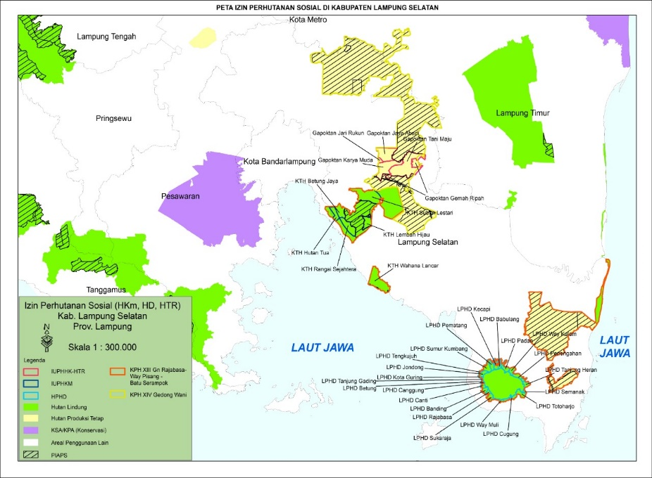
2 | Lima Puluh Kota District, West Sumatra Province | S 0°01′00″  E 100°35′14″ | The district is in the eastern part of the Sumatran mountain range and is famous as a jewel of West Sumatra. There are several protected areas and recreation places including Lembah Harau Nature Reserve and Forest Recreation Area of Lembah Harau. The nature reserves and the adjacent forest areas are habitat for Sumatran endangered wildlife such as critically endangered Sumatran tiger.  The proposed project site covers a total area of 110, 559 ha of upland and semi upland forest, comprising of Community Forestry/HKm (5,400 ha + 39,643 Ha) and Village Forest/HD (25,912 ha +39,643 ha) which all scatters adjacent to the nature reserve and forest protection areas in the district. As such, this site will serve as the social economic buffer for the forest areas.  The local communities have long tradition to manage forest area called, hutan nagari. Hence, local communities can continue managing the area by formally receiving its use rights under the social forestry program through the project support. It is expected to enhance the management of these forests and maintain the adjacent forest and/or protected areas sustainably. | 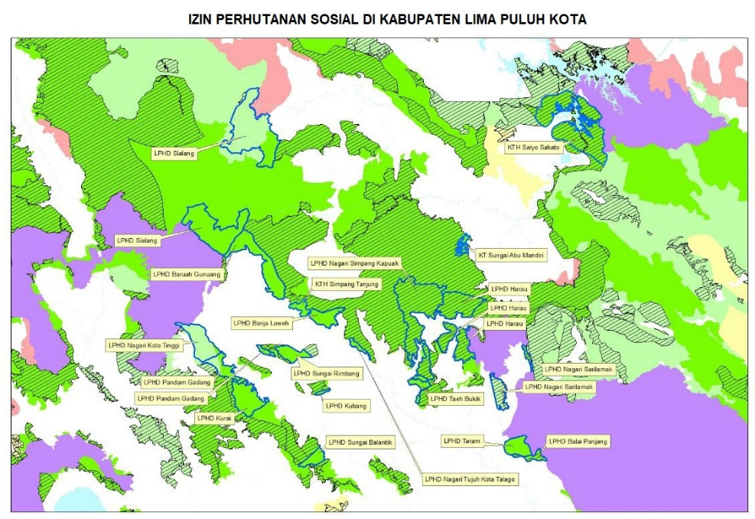
3  4 & 5 | Dompu, West Nusa Tenggara  Bima, West Nusa Tenggara | S 8°36′00″  E 118°37′00″  S 8°30′34″  E 118°28′54″ | The two districts (Bima and Dompu) is administratively located within West Nusa Tenggara Barat Province.  The proposed project site in Bima District covers total area of 63,821 ha, which will be allocated for Community Forestry/HKm. While in Dompu District the project site covers total area of 53, 444 ha which consist of Community Forestry/HKm (52,811 ha), Community Timber Plantation/HTR (324.75 ha) and Forestry Partnership/Kemitraan (309 ha). Granting these forests areas to the community through social forestry programs is expected to improve the prosperity of the community while recovering and rehabilitating degraded area into forests.  Forest area in Bima District are known for habitat of more than 7 species of medicinal plants. Dompu District is well known for the biodiversity richness. Based on recent exploration by the Indonesian Institute of Sciences, 625 species of flora and fauna, in particular birds and insects discovered in Dompu especially within the Tambora National Park. | 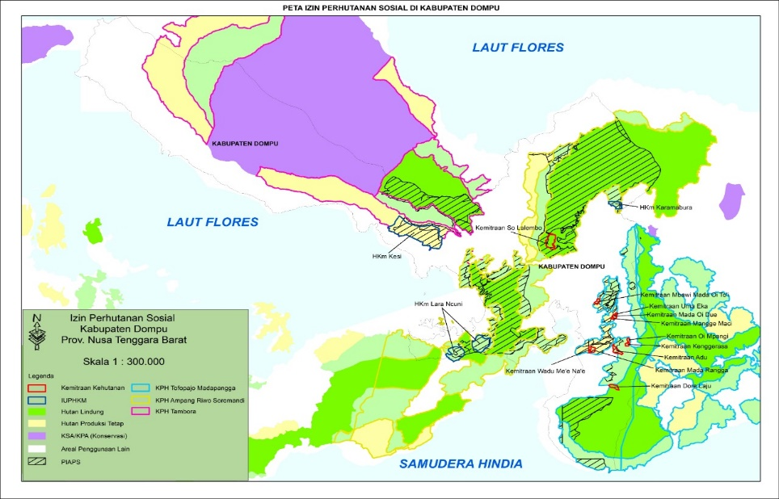  Dompu, West Nusa Tenggara  Bima, West Nusa Tenggara  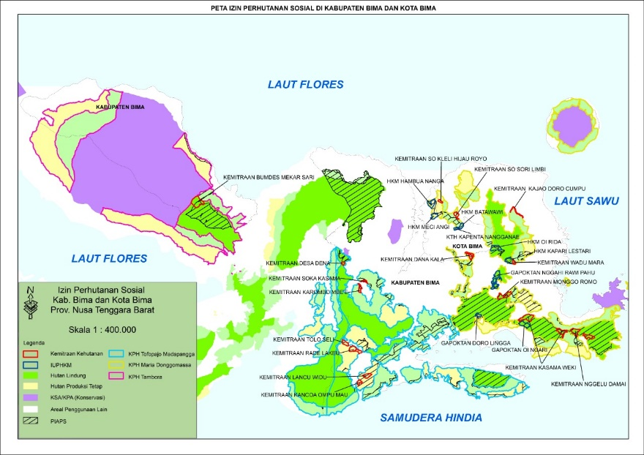
6 | West Halmahera District, Maluku Province | N 1°25′02″  E 127°33′10″ | Halmahera island is one of the biodiversity hot spots within the Wallace ecoregion categorized and characterized by numerous of endemic or near endemic species including 43 bird species e.g, Cacatua alba and Eos squamata, 9 mammal species such as Phalangeridae phalanger and a number of herpetofauna species.  A total of 22, 743 ha of forest area within the administrative District of Halmahera Barat has been granted to the community in the scheme of HKM (5,6614 ha), HD (6,453 ha), HTR (7,010 ha) and KK (3,664 ha) with the aim to improve prosperity while maintain the forest area sustainably. | 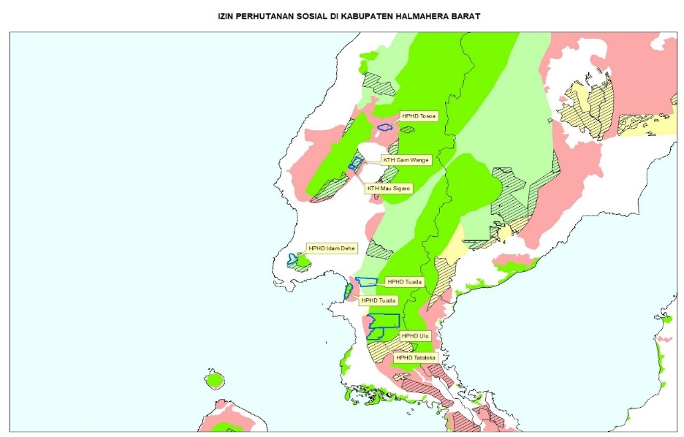
* the project has seven sites. Six have been selected based on the pre-identified criteria, while the seventh site will be determined during project implementation.

Figure 1.1: Location of 6 Project Sites:
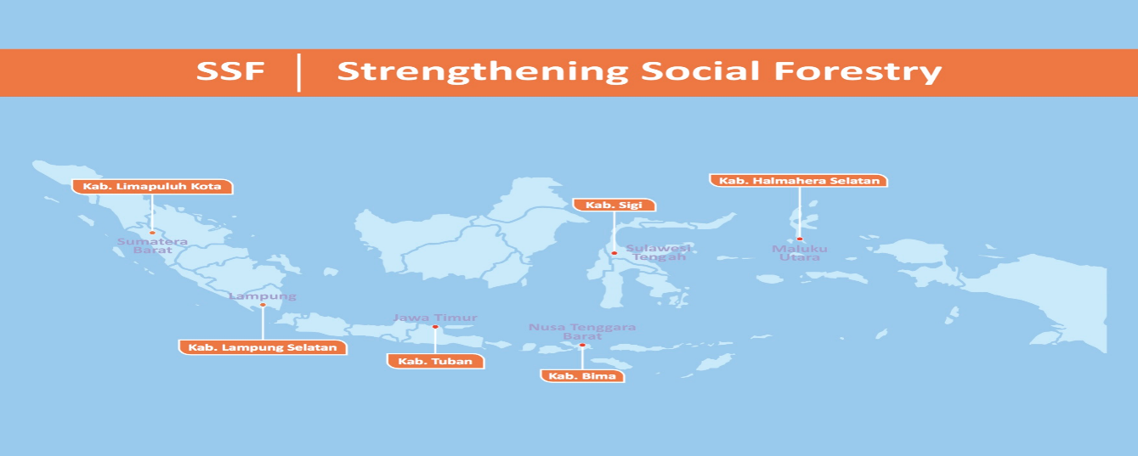
Note: The project has seven sites. Six have been selected based on preidentified criteria, while the seventh site will be determined during project implementation (Tuban District will be replaced by other site)
Table 1.2 FIP-2 Supported FMUs in the SSF Project sites
No | District/Province | Existing FMUs in the SSF Project | Existing FMUs in other World Bank financed projects
1 | South Lampung District, Lampung Province | - Protected Forest Management Unit (KPHL) Model Rajabasa (total area extent: + 5,160 hectares)  - Production Forest Management Unit (KPHP) Model Gedong Wani (total area extent: + 30,243 hectares)  - Production Forest Management Unit (KPHP) Model Gedong Wani (total area extent: + 1,004,735 hectares).
2 | Limapuluh Kota District, West Sumatra Province | - Protected Forest Management Unit (KPHL) Bukit Barisan (total area extent: ± 86,511 hectares)  - Protected Forest Management Unit (KPHL) Lima Puluh Kota (total area extent: ± 117,552 hectares)  - Protected Forest Management Unit (KPHL) Hulu Batanghari
3 | Dompu District, West Nusa Tenggara Province | - Protected Forest Management Unit (KPHL) Toffo Pajo Unit XVI
4 & 5 | Bima District, West Nusa Tenggara Province | - Forest Management Unit Tambora (total area extent: 57,181 hectares)  - Forest Management Unit Toffo Pajo Madapangga Rompu Waworada (total area extent: 96,607 hectares)  - Production Forest Management Unit (KPHP) Maria Donggomassa (total area extent: 70,651 hectares) | 2 FMUs in West Nusa Tenggara Province, supported by FIP2 (World Bank):  - Protection Forest Management Unit (KPHL) Rinjani Barat di Propinsi NTB  - Production Forest Management Unit (KPHP) Batulanteh  5 customary area/communities supported by DGM Indonesia
6 | West Halmahera District, Maluku Province | - Protected Forest Management Unit (KPHL) West Halmahera (total area extent: 140,808 hectares)  - Production Forest Management Unit (KPHP) Bacan  - Production Forest Management Unit (KPHP) Mount Sinopa (total area extent: ± 44,577 hectares)

Figure 1.2: Map of project sites supported by FIP Program, DGM Indonesia Project and SSF Project

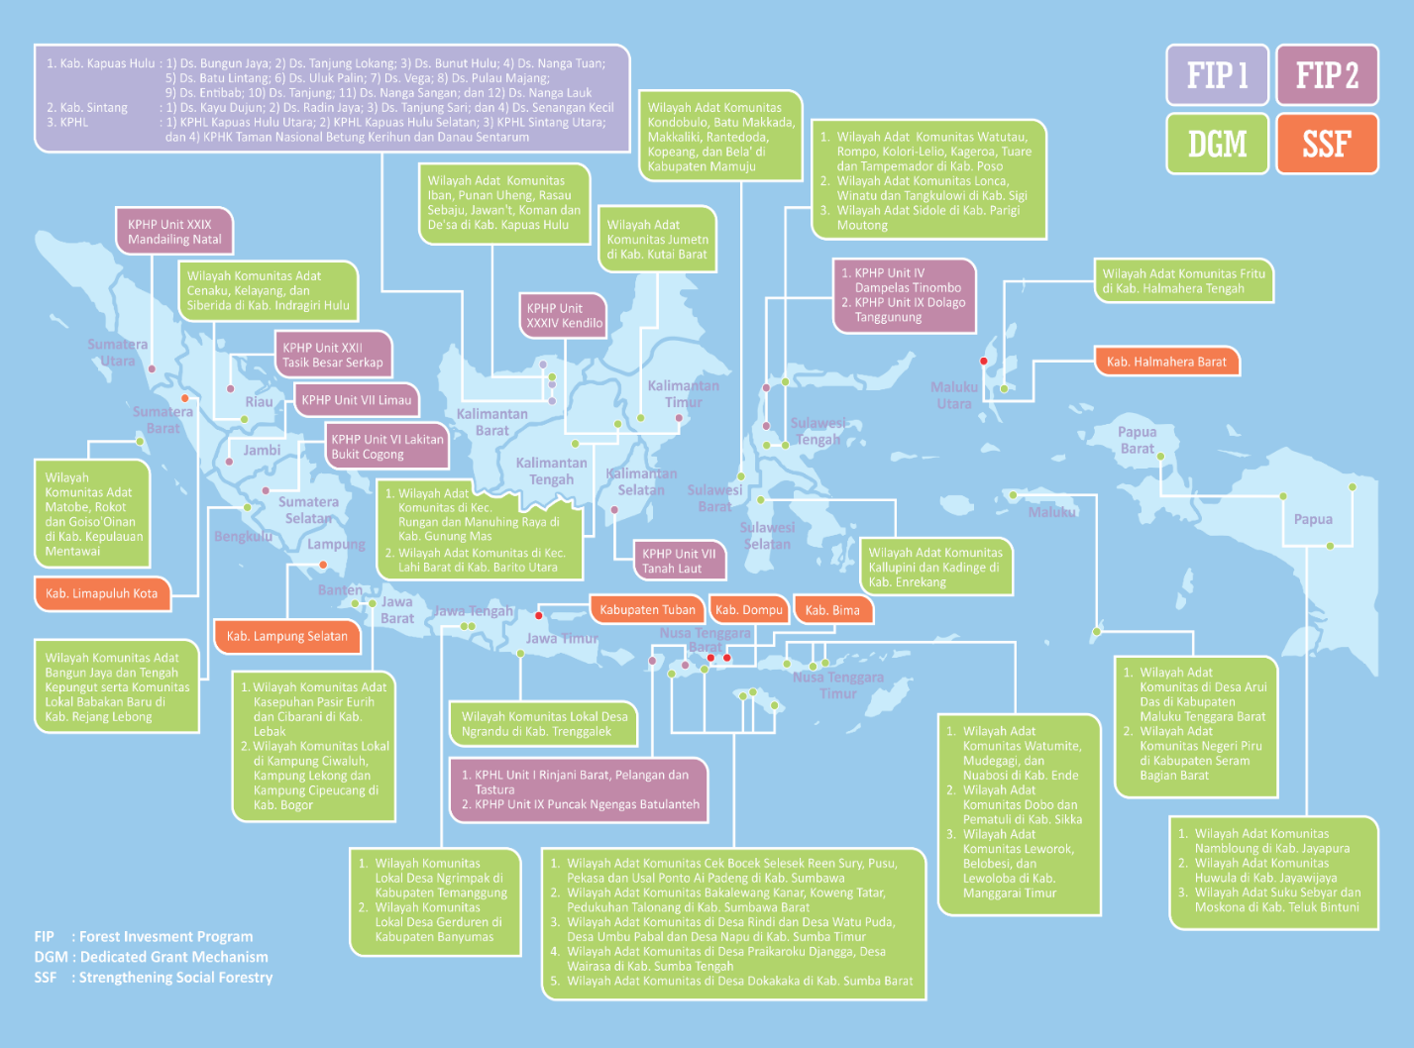

World Bank 2018a.
World Bank 2018b.
GDP breakdown by sector is as follows: agriculture represents 34 percent, forestry and logging 0.19 percent, and mining and quarrying 9.8 percent.
Badan Pusat Statistik (BPS).
The term adat communities is often used to describe indigenous and other groups practicing communal or customary tenure.
Data are from the National Social and Economic Survey (Survei Sosial Ekonomi Nasional, SUSENA) and Village Census (Pendataan Potensi Desa, PODES).
Indonesia’s Forest Areas (Kawasan Hutan) are divided into three major classifications based on forest functions. Protection Forest (Hutan Lindung) is one of the three main types of forest area. Its main function is to serve as a buffer system so that water systems can be regulated, floods prevented, erosion controlled, seawater intrusion prevented, and soil fertility maintained. Conservation Forest (Hutan Konservasi) is one of the Forest Area’s three main administrative classifications and is assigned to forests set aside for the purpose of conserving the diversity of plants and animals and their ecosystems. Production Forest (Hutan Produksi) is one of the three main types of Forest Area. Its main function is to produce forest products (MoEF 2018a).
FAO 2016.
MoEF 2018a.
UNEP / UNORCID 2015.
120.6 million ha, or 63 percent of the nation’s entire land area designated as the Forest Areas (Kawasan Hutan). Most of Indonesia’s remaining land area is made up of non-forestlands, known as Areas for Other Purposes (Areal Penggunaan Lain, or APL). The Forest Areas are managed in accordance with three functions. Production Forests (Hutan Produksi, HP) cover 68.8 million ha, or 57 percent of the Forest Area. Conservation Forests (Hutan Konservasi) cover 22.1 million ha, or 18 percent (with an additional 5.3 million ha of marine conservation areas). Protection Forests (Hutan Lindung) cover the remaining 29.7 million ha, or 25 percent (MoEF 2018a).
Uryu et al. 2008.
Article 19 Law 5/1960 and Article 9 of Government Regulation 24/1997.
Titled land means land that is encumbered by tenure right.
Thorburn and Kull 2015.
Utama and Irsan 2014.
According to Constitutional Court ruling No. 35/2013, customary forests (Hutan Adat) were no longer part of State Forests (Hutan Negara), which are Forest Areas (Kawansan Hutan) controlled by the state, as long as it is legally released or recognized by the government. Once the Hutan Adat is recognized, the area becomes Titled Forests (Hutan Hak). There are three types of Titled Forest: individual titled forest, legal entity titled forest, and Adat Forest.
MoEF 2018a.
Riau, Jambi, South Sumatra, West Kalimantan, East Kalimantan, Central Kalimantan, South Kalimantan, and Papua.
The proposed project does not address poaching and the illegal harvest of wildlife directly, these are however supported by a separate GEF grant being implemented by United Nations Development Programme (UNDP), through the Combatting Illegal and Unsustainable Trade in Endangered Species in Indonesia project. However, the proposed SSF project would would also reduce threats to wildlife by engaging communities in conservation and sustainable livelihood activities in forest areas. The proposed SSF project is also coordinating with projects and activities supported by the KfW/GiZ and Food and Agriculture Organization (FAO) that contribute to the strengthening the GOI’s SSP, thereby, enhancing synergy and reducing duplications.
Minister of Environment and Forestry Decree No. P.83/MENLHK/SETJEN/KUM.1/10/2016 on Social Forestry.
The definition of Social Forestry includes Community Forest (Hutan Rakyat) and Adat Forest as the forms of Social Forestry schemes (Article 1 MoEF 83/2016).
Source: Ministry of Finance, Climate Budget Tagging Exercise, 2018.
Source: Ministry of Finance, Climate Budget Tagging Exercise, 2018.
As of November 2017, the Directorate General on Social Forestry and Environmental Partnerships at the MoEF presented a progress report on achieving the social forestry targets on almost 1.1 million ha. To achieve the social forestry targets of an additional 11.6 million ha by 2019, social forestry implementation will need to be expedited after 2017, which helps explain the significant increase in budget funds allocated for social forestry in 2018. See Fisher et al. (2018) for additional information.
https://blup3h.id/penandatanganan-perjanjian-pinjaman-blora/.
https://www.recoftc.org/en/indonesia/projects/raft3-indonesia/news/linking-community-forestry-business-units-funding-sources.
http://pattiro.org/2018/03/optimalisasi-penggunaan-dbh-dr-untuk-percepatan-perhutanan-sosial/?lang=en.
https://climatepolicyinitiative.org/publication/indonesias-village-fund-an-important-lever-for-better-land-use-and-economic-growth-at-the-local-level/.
MoEF 2018a.
MoEF 2018a.
The project contributes to Indonesia’s 2nd NBSAP dated 2004 which is 12 years old. However, Indonesia recently launched it updated IBSAP. The project would contribute to IBSAP and the design will incorporate its objectives. The project is also consistent with the National Report to the CBD dated 2015 (https://www.cbd.int/doc/world/id/id-nr-05-en.pdf). The report notes that social forestry is an important GOI program to address land degradation, strengthen biodiversity conservation, adaptation to climate change as well as mitigation objectives. Both the need to reduce deforestation, land degradation and biodiversity losses as well as to strengthen rehabilitation through mainstreaming programs such as social forestry is recognized. Furthermore, the 2015 GOI supported Indonesia Land Degradation Neutrality report also notes that Indonesia’s program for addressing land degradation which is consistent with the proposed project. One of the most important national policy references to social forestry is to be found in Indonesia’s Nationally Determined Contribution (NDC).
The tenth meeting of the Conference of the Parties, held in October 2010, in Nagoya (Aichi Prefecture in Japan), adopted a revised and updated Strategic Plan for Biodiversity, including the Aichi Biodiversity Targets, for the 2011-2020 period. It is a ten-year framework for action by all countries and stakeholders to save biodiversity and enhance its benefits for people. The proposed project would contribute to the following targets: (i) Target 1 – by 2020, at the latest, people are aware of the values of biodiversity and the steps they can take to conserve and use it sustainably; (ii) Target 7 – by 2020 areas under agriculture, aquaculture and forestry are managed sustainably, ensuring conservation of biodiversity; (iii) Target 15 – by 2020, ecosystem resilience and the contribution of biodiversity to carbon stocks have been enhanced; and (iv) Target 18 – by 2020, 2020, the traditional knowledge, innovations and practices of indigenous and local communities relevant for the conservation and sustainable use of biodiversity, and their customary use of biological resources, are respected.
GOI (2006). Nationally Determined Contributions (NDCs – UNFCCC).
Ibid.
Julian Quan and Nat Dyer (2008). Climate Change and Land Tenure, the Implications of Climate Change for Land Tenure and Land Policy, FAO, Rome.
The project will support the mapping and demarcation of social forestry plots within the area that has already been identified as part of the Indicative Map of Social Forestry area (Peta Indicative Area Perhutanan Sosial, PIAPS), or areas under TORA processes whose lands are to be released from state forest, but where maintaining or rehabilitating forest cover is identified as a necessity in the project’s ESMF.
Perdirjen PSKL P.14/PSKL/SET/PSL.0/ 11/2016 tentang Petunjuk Fasilitasi Pembentukan dan Tata Cara Kerja Kelompok Kerja Percepatan Perhutanan Sosial.

